Title

1. Bluetooth communications

* Connect Arduino and mobile phone via bluetooth
* Control LED on/off from mobile phone
* Display temperature value on mobile phone

Hardware Required

Arduino, module bluetooth, temperature sensor, led, mobile phone

Theory

Connect blutooth to App Serial Bluetooth Terminal, display tempature in app, control led on/ off.

Circuit

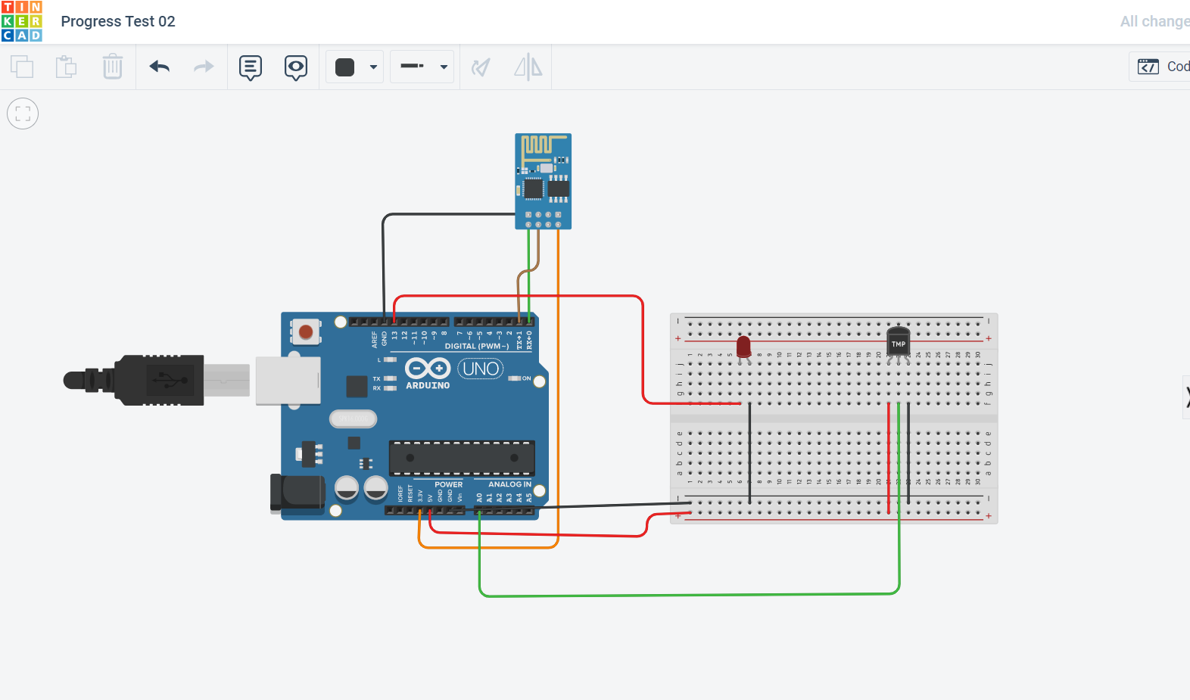

Temperature sensor:

LEFT: 5V

MID: A0

RIGHT: GND

Bluetooth HC-05:

RX -> TX

TX -> RX

GND ->GND

Vcc -> 3.3V

LED:

Cathode: GND

Anode: 11

Code

char Incoming_value = 0;

int s = 0;

float volt = 0.0;

void setup()

{

Serial.begin(9600);

pinMode(13, OUTPUT);

}

void loop()

{

{

Incoming_value = Serial.read();

Serial.print(Incoming_value);

Serial.print("\n");

if(Incoming_value == '1')

digitalWrite(13, HIGH);

else if(Incoming_value == '0')

digitalWrite(13, LOW);

s = analogRead(A0); // 0 ~~ 1023

volt = s * 5.0 / 1023;

float temp = volt*100; // 0.01V = 1℃

Serial.print("The temperature is :");

Serial.print(temp);

delay(2000);

}

}

Demonstrations

References

<https://howtomechatronics.com/tutorials/arduino/arduino-and-hc-05-bluetooth-module-tutorial/>